Due to the size, the folders that can be installed have been removed. Here is the process to install them back:
This document is divided into a few steps, from hardest to easiest:
Step 1: Set the local Database to store the data
- Download MongoDB community Server
  - https://www.mongodb.com/try/download/community
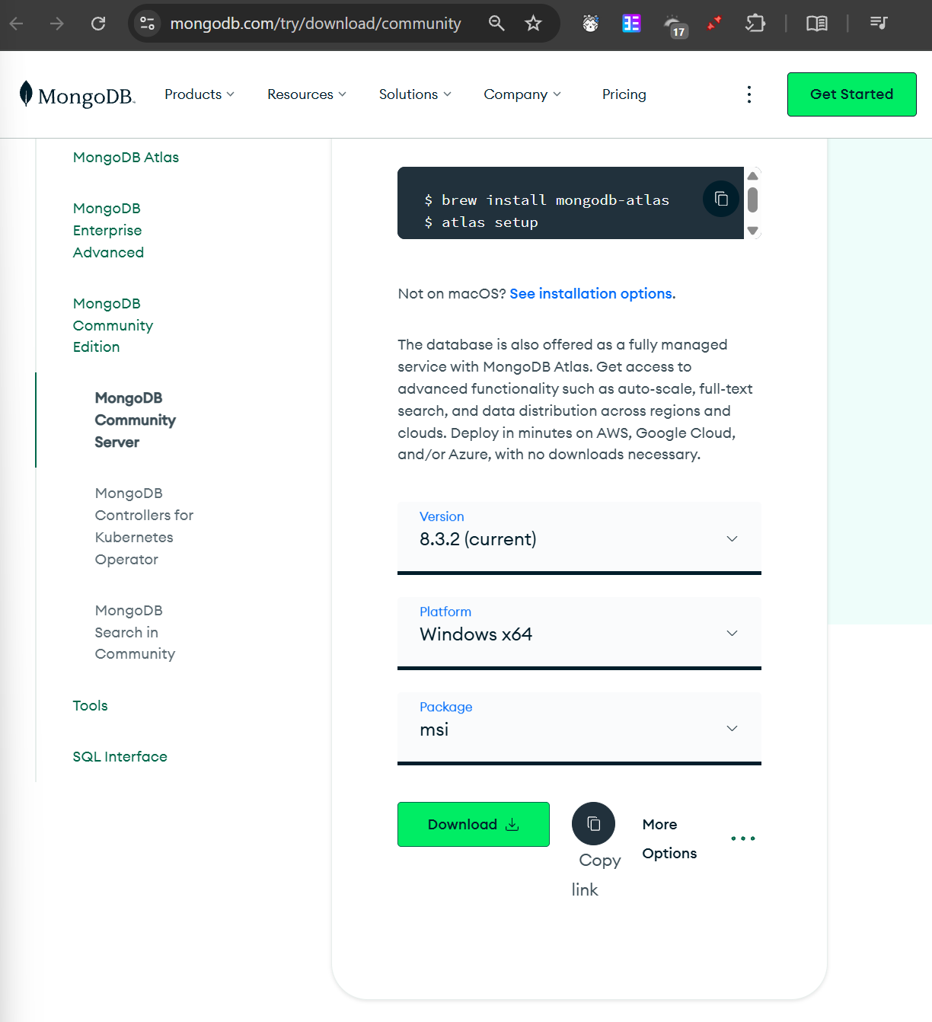

- Install the file.
  - Choose the Complete installation setup option.
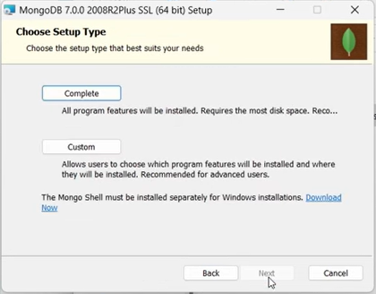
  - Make sure the checkbox for "Run service as a Network Service user" or "Install MongoDB as a Service" is checked.
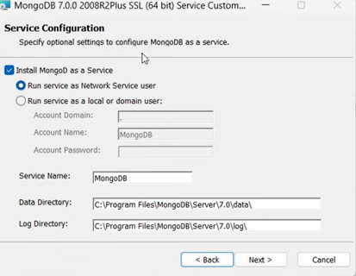

- The installer will ask if you want to install "MongoDB Compass."
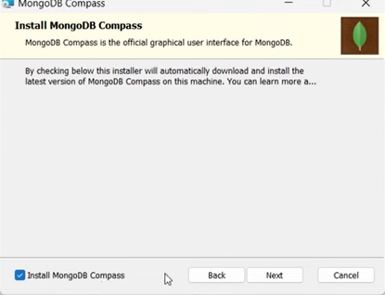

- Use the default connection

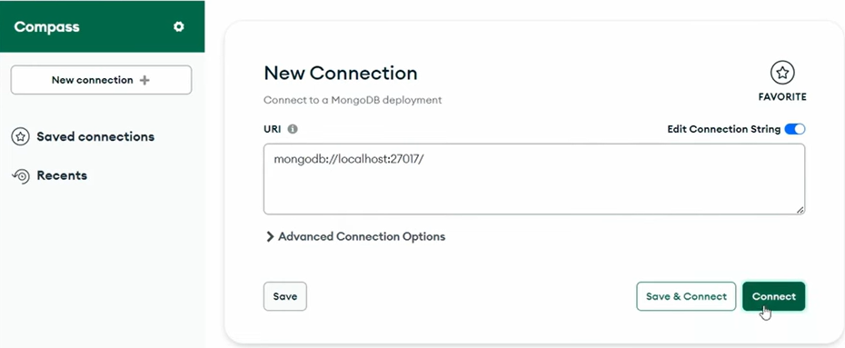

- Add a new database
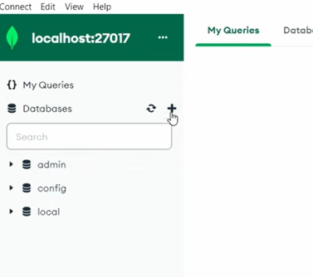

- Name the data base as: booking_system
  - This process is very important otherwise you may need to change other information.
  - Create a random collection, because with creating a random collection is not possible to continue. Your name or something

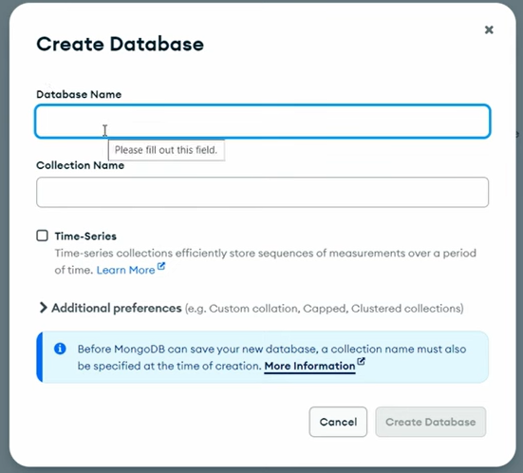

  - Make sure in the file: `backend/.env`
    - After the `localhost/27017/` The follow name in the same as in the DB
      - If you did not use the default value, make sure that the numbers are correct too.

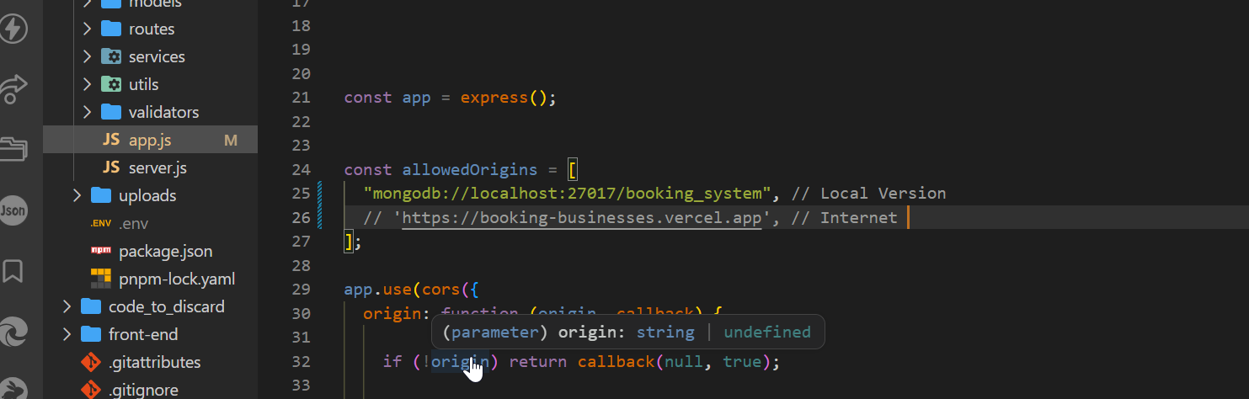

Step 2: Installing the frontend

- Move to the path in the terminal
  - `cd backend`
- Install the modules
  - `npm install`

Step 2: Installing the backend server
- Move to the path in the terminal
  - `cd ..`
  - `cd front-end`
- Install the modules
  - `npm install`

Step 3: Running the backend server and frontend
- This will start the backend server
  - Move to the path in the terminal
    - `cd ..`
    - `cd backend`
    - `npm run dev`
- This will start the front-end
  - Move to the path in the terminal
    - `cd ..`
    - `cd front-end`
    - `npm run dev`
- How the website is running.

